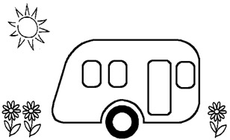 AFIA Beetle
Throw a 6 for a body to start  First person to complete a caravan shouts ‘AFIA’ and the game stops.  Count 1 pt for each body part  (10 for a complete Caravan) | 6 Caravan  5 Sun  4 Flowers x3 | 3 Window x3  2 Door  1 Wheel

Total _____

