

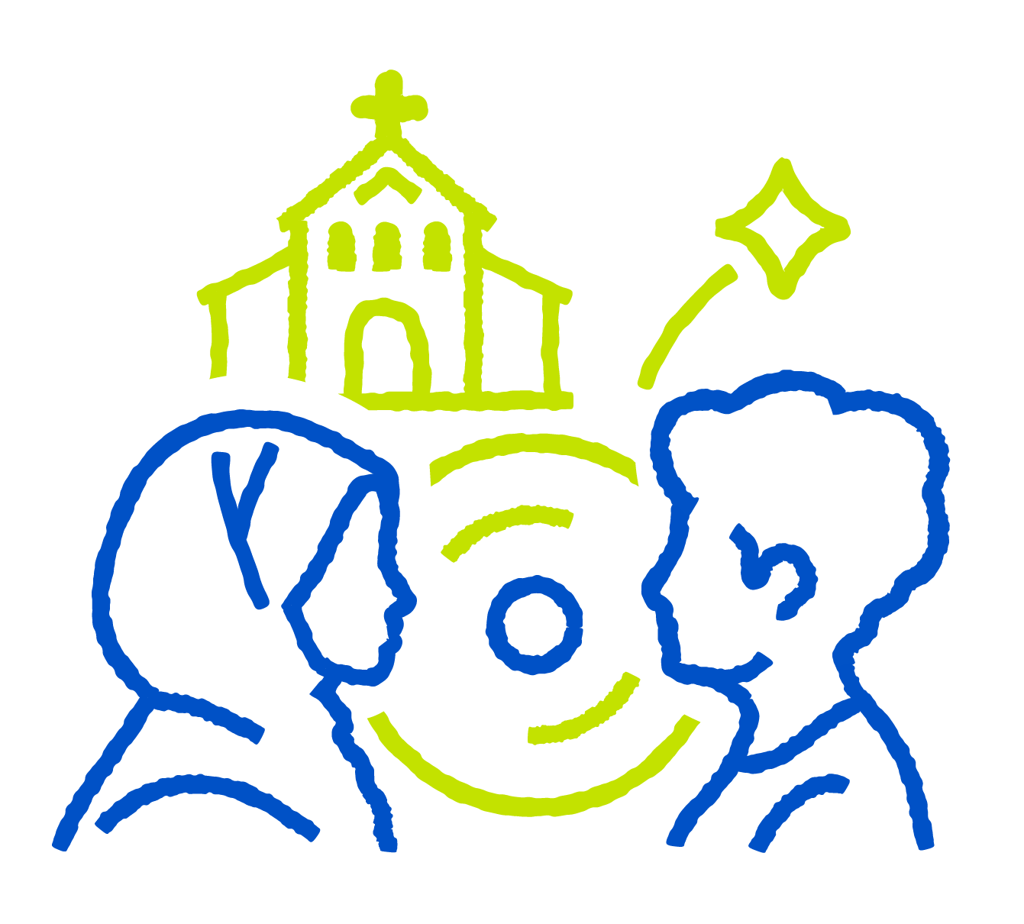

Autumn Council
30 November 2025
6pm
St Francis Church Hall Bramley S66 2SQ
Come Along and find out what’s happening!

